**Online Quiz Portal Output**

**User Module**

**Index Page**

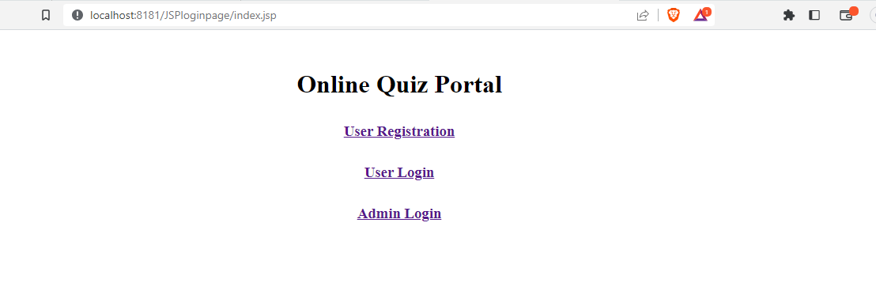

**User Registration Page**

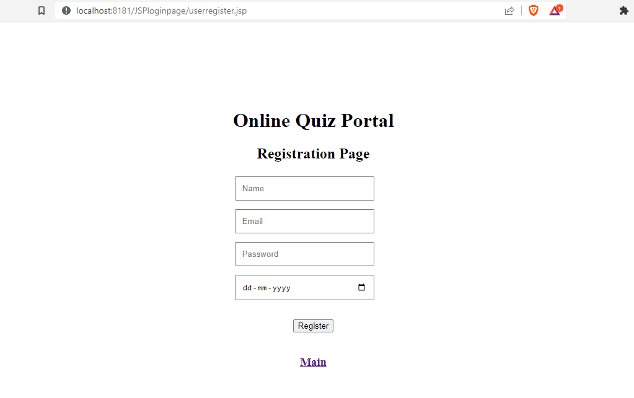

**User Login Page**

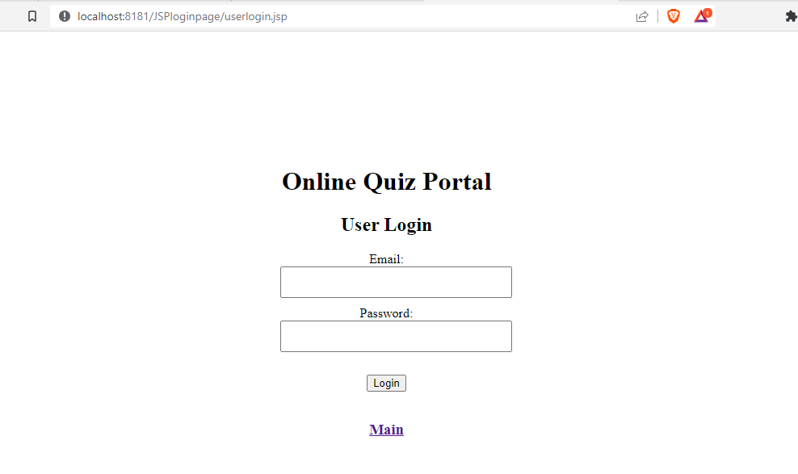

**User Dashboard Page**

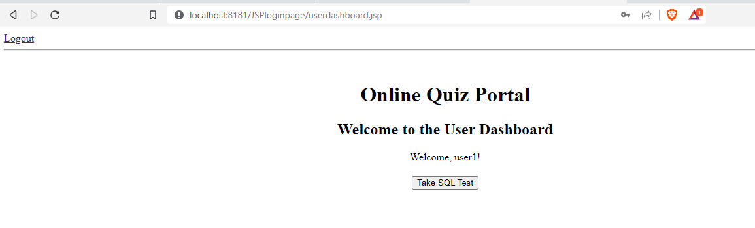

**Test Page**

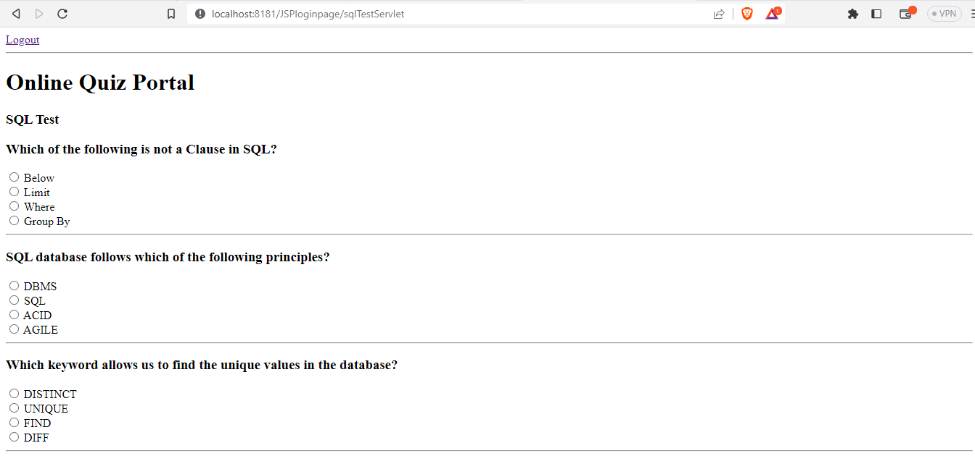

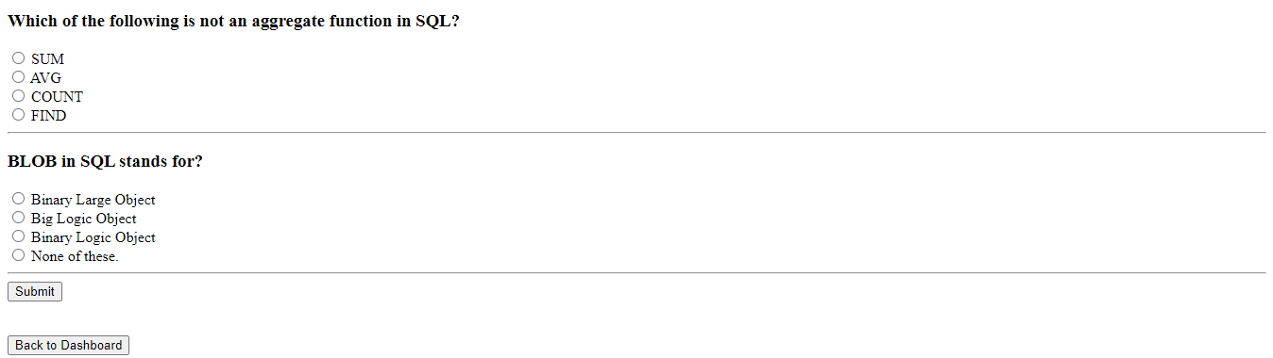

**Test Score Page**

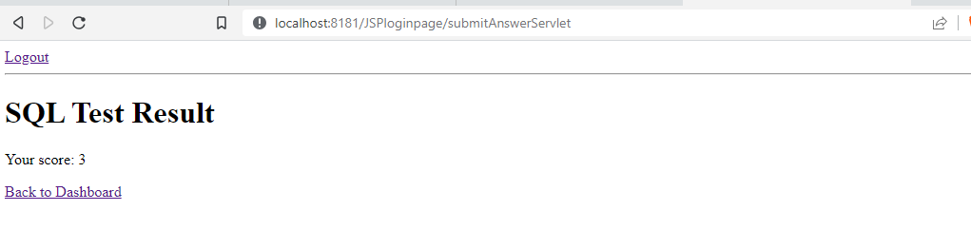

**Logout Page**

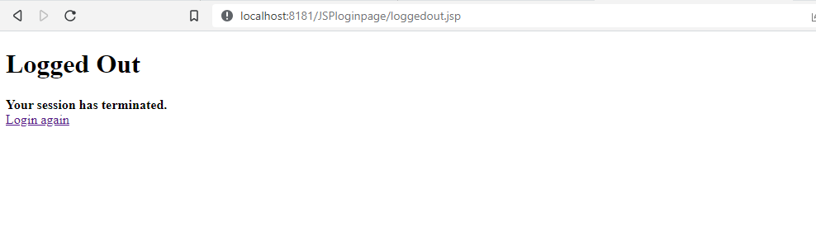

**Admin Module**

**Admin Login Page**

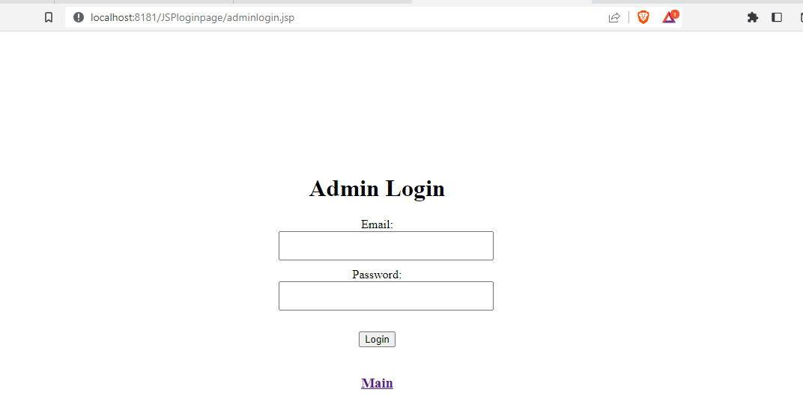

**Admin Dashboard Page**

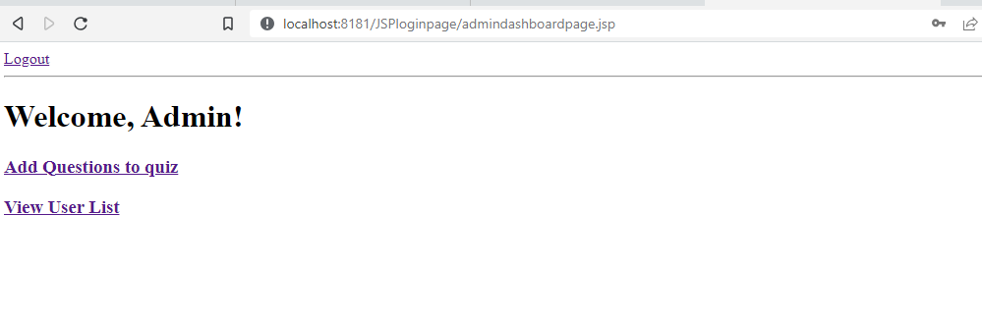

**Add Quiz Page**

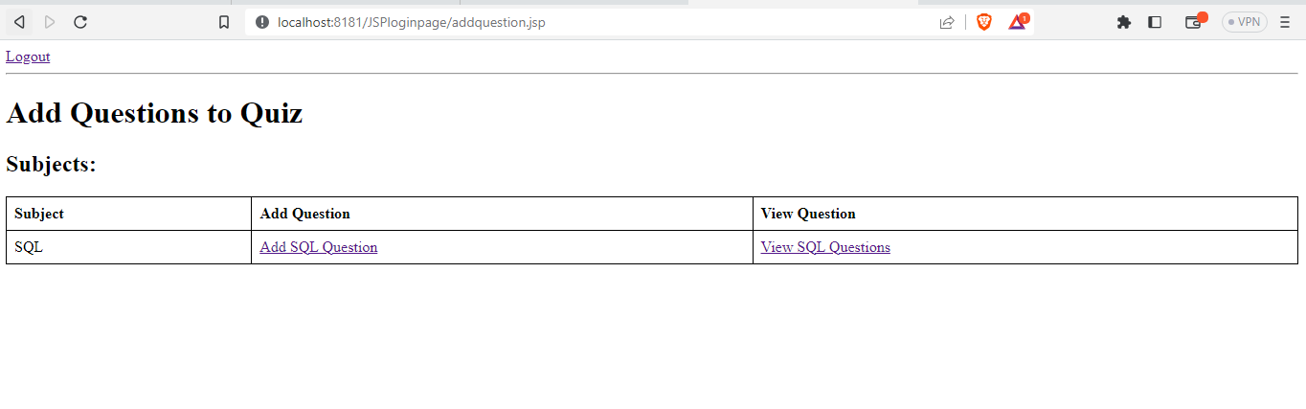

**Add SQL Question Page**

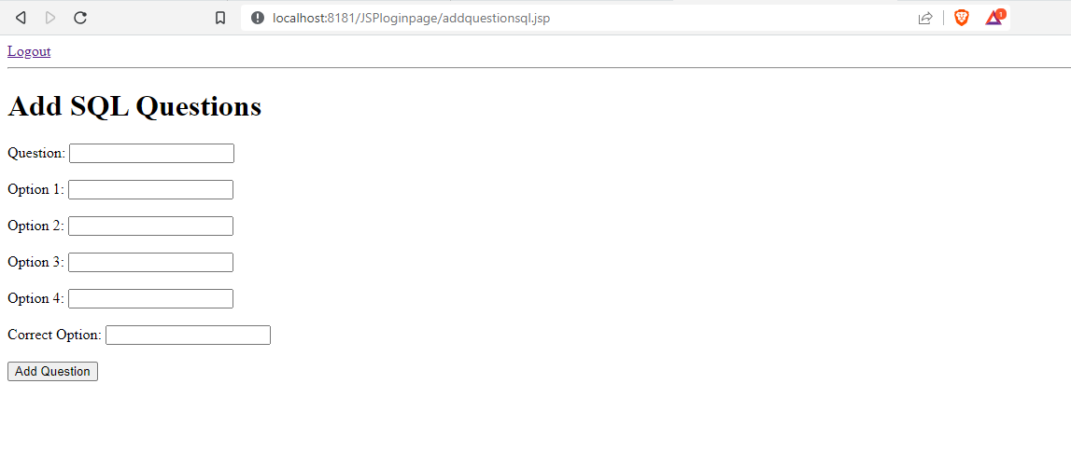

**View Added Question Page**

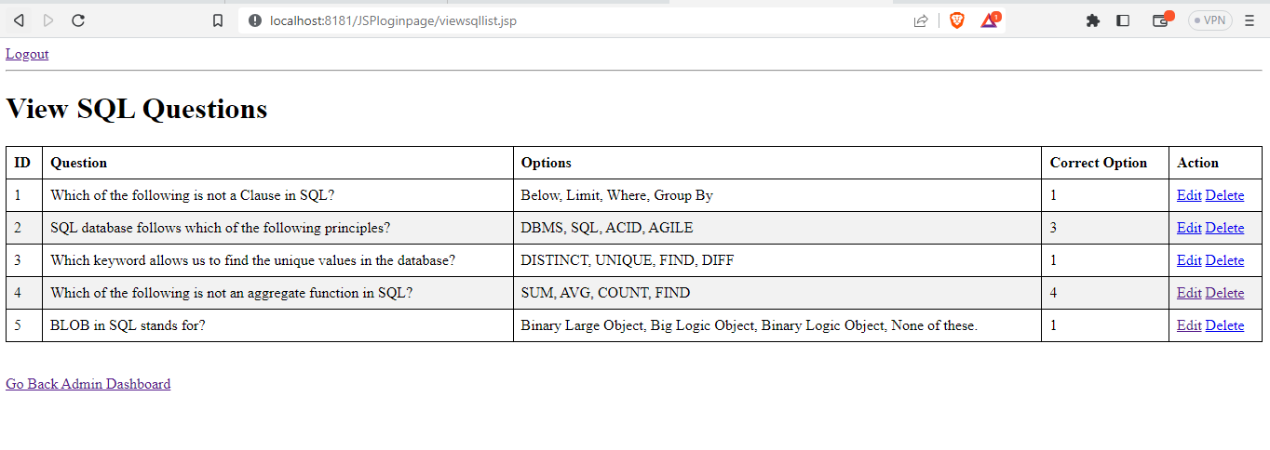

**View UserList Page**

